Brief of DGFP Supply ChaiN Information Portal (SCIP)

The DGFP Supply Chain Information Portal is a Central Portal for DGFP Tools developed by the Strengthening Pharmaceutical Systems (SPS) Program with support of the USAID for the Directorate General of Family Planning (DGFP) under Ministry of Health & Family Welfare (MOHFW). The Supply Chain Information Portal (SCIP) helps to ensure availability of RH commodities at all levels, which eventually help reduce unwanted pregnancies and population growth—steps toward reaching the relevant Millennium Development Goals. National, regional and Upazila (sub-district) officials of Directorate General of Family Planning (DGFP) enter procurement and logistics related data in the portal and the dashboard presents Charts, Maps and Tables for decision makers. The portal is unique in terms of information management in the public sector.

To browse the site, just point your browser to http://www.dgfplmis.org and register to get a free account to view the information available in the SCIP. Or you can use the default viewer Id/Pwd –
User Id: dgfpcommon
Password: dgfpcommon

DGFP Logistics Tools

There are 4 major blocks in the portal:
- Procurement Tracker
- LMIS
- Stock Status Report &
- Operational Status of Tools

Apart from these blocks the portal has a Menu bar on the left side where we will find brief about DGFP and their supply chain and logistics system, brief about the logistics tools, a discussion board, documents archive & registration. People registering from the front page can only view the dashboards and data of the web site and the four modules require id/password to access.

Registration
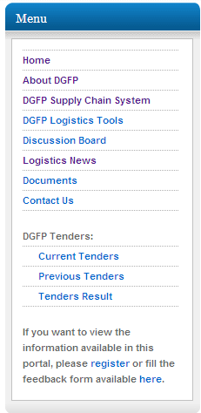
To go inside SCIP you need to register.

Step-1: Click on the register link at the front page of SCIP.

Step-2: Fill up the following form and submit for registration.

Step-3: By submitting the filled form your registration is completed, but not your account will not be activated till you get a confirmation mail into your email address.

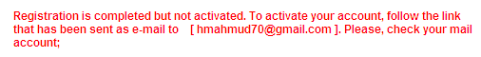

Step-4: If you want to activate your account you have to follow the link provided in your e-mail.
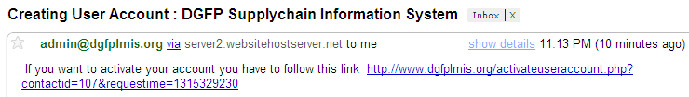

Step-5: After clicking this link you will be taken to the SCIP and will see the message -

You are ready to access the password protected pages of SCIP portal. SCIP has single log-on, so if you log-in in the first page, the modules will be automatically accessible. Or logging in any module will allow you to access the other modules.
Procurement Tracker
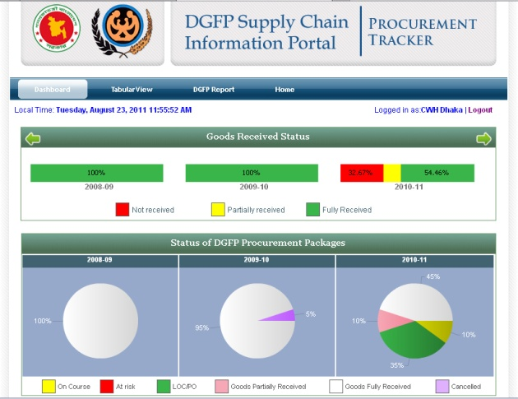
The Procurement Tracker (PT) is a web-based tool which allows monitoring of procurement packages in a single location. PT provides information on procurement delays & bottlenecks which facilitates management decision making.

Advantages -
- Allows monitoring of procurement packages through interactive Dashboard.
- Procurement packages are monitored by milestones and delays trigger automated alerts.
- Drills down for detailed information on progress of procurement packages.
- Helps to reduce lead time of procurement processes
- Facilitates efficient and effective procurement management.
- Promotes transparency.
- Secure site with encrypted data transfer.
If you have not logged on already, click on the LOG IN button under the Procurement Tracker box, and provide your username/password in the boxes and press LOG IN button again. This will open the PT Dashboard.

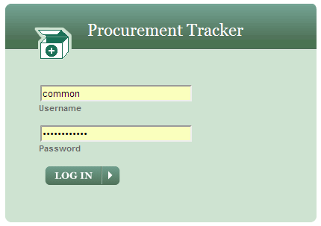

Dashboard
The first tab of Procurement Tracker is Dashboard showing consecutive three years data which has three major blocks:
- Goods Received Status: The goods received data have shown here in a line bar for each year which shows commodity receive status for procurement of any specific year. There are three types of status – Not received, Partially received and Fully received; which is represented by Red, Yellow & Green color respectively.
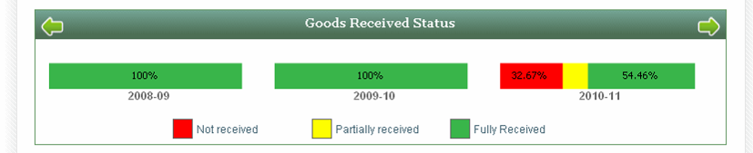

- Status of DGFP Procurement Packages: The next block shows overall procurement status as a pie chart divided into six procurement stages – On course, At risk, LOC/PO, Goods partially received, Goods fully received and cancelled;

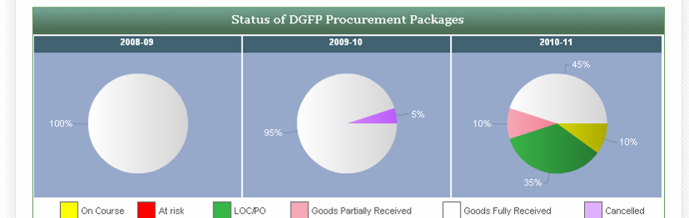
- Status of any year’s Procurement Packages by milestone: The long procurement cycle has been broken into milestones and packages monitored against that. This block shows details milestone status of each package. If any package is delayed then the milestone color becomes Yellow or Red based on duration of delay which assists in monitoring.

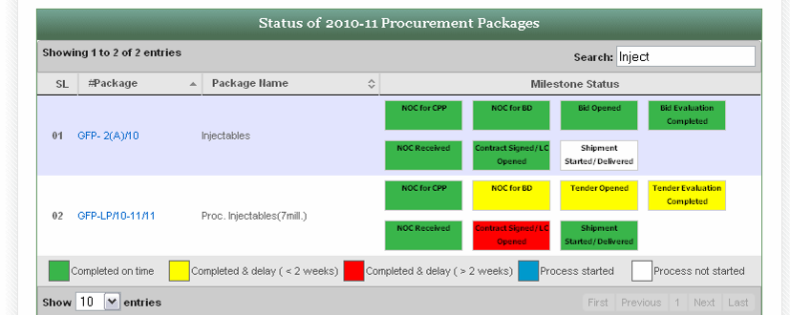

If you put the cursor on a milestone a dialogue box will appear with details of that milestone, weeks delayed etc.

Tabular View
The second tab of the Procurement Tracker is Tabular View of the Procurement Packages. First select the financial year for which you want to view the package list. This will refresh the Package List. Ten packages data have shown in the front page at a time. The list will show Package#, Name, Start Date, Estimated Cost, Source of Fund, Procurement Method etc.

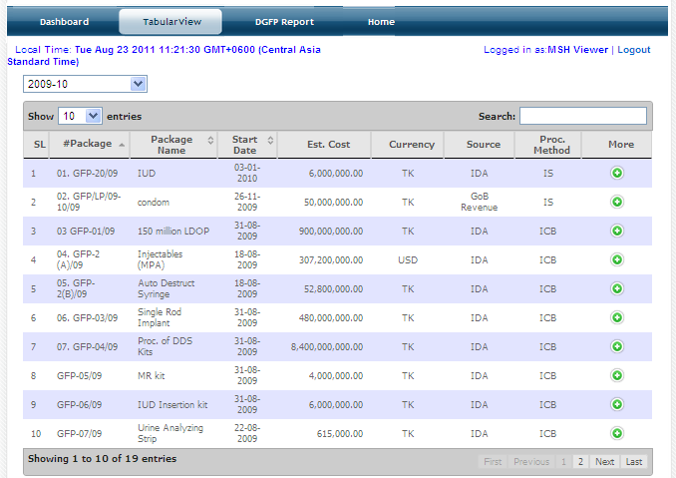

When you select a package from the list, below the list you will see four tabs with more information about:
- Package Status
- Items
- Contracts and
- Receipts

Package Status – Will show the steps of the procurement package and the date of every step.

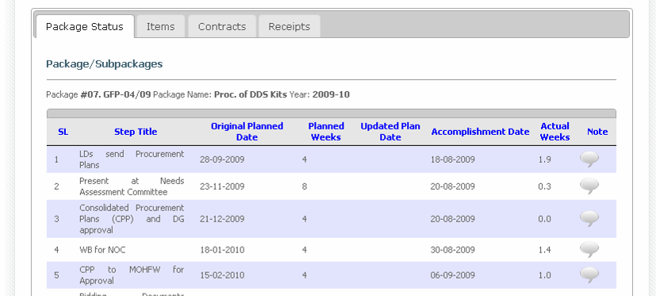

Items – Shows the commodities which will be procured under this package.

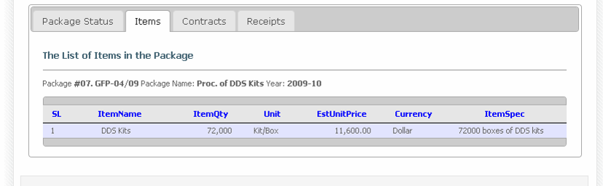

Contracts – The sub-packages, contracts & contract items under this package.

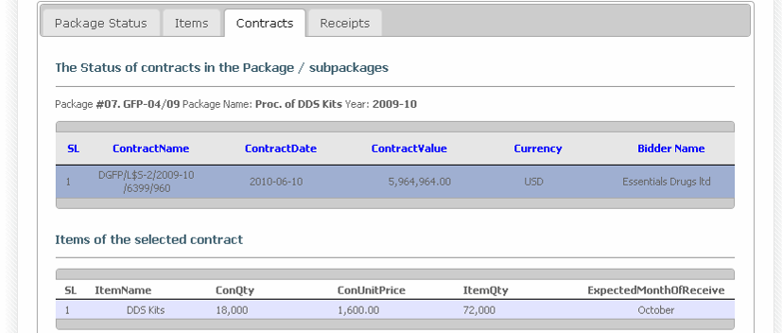

Receipts – Receipt of commodities under this package/contracts.

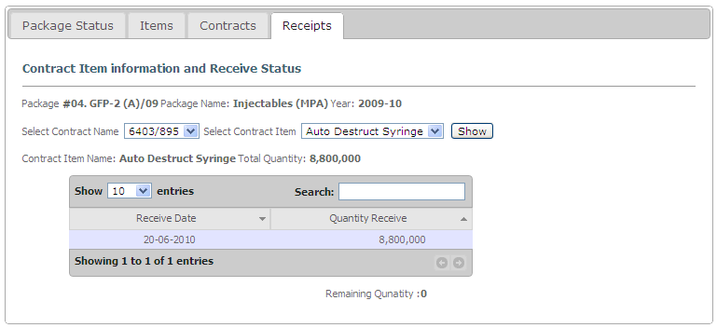

DGFP Report

The third tab of the Procurement Tracker is DGFP Report of the Procurement Packages. Two types of reports are available:
- Single Package
- Package Summary

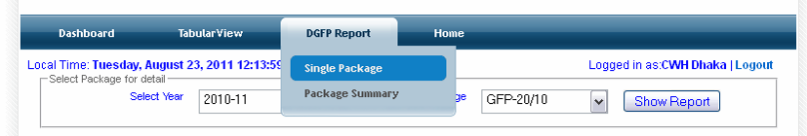

Single Package
To see a single package data you need to select a year and a package, then press Show Report button.

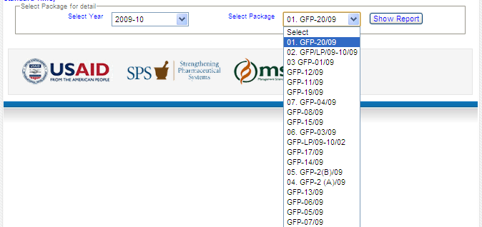

The data will arrive in the following window.

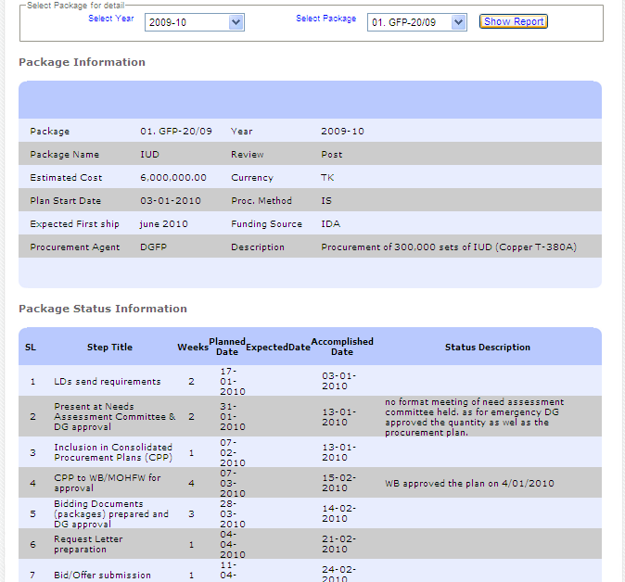

Package Summary
If you want to see Packages Summary data you need to select only the year and press Show Report button.

The report will be available –

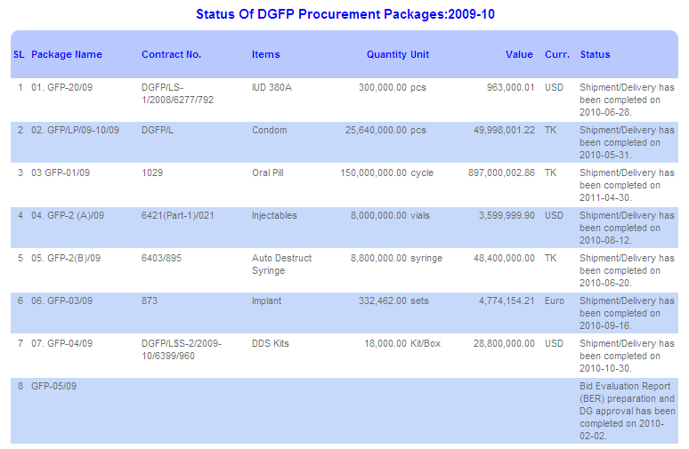

LMIS: Logistics Management Information System

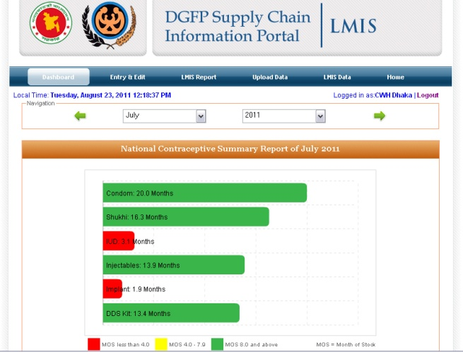
The web-based Logistics Management Information System (LMIS) is a tool which acts as a central repository of logistics data of RH commodities. LMIS maintains stock status of commodities and consumption data from all tiers.
Advantages:
- Monitoring of stock position at all levels through interactive Dashboard.
- Allows monitoring of consumption trend of RH commodities.
- Quickly identify Upazila (Sub-district) & field level stock-out situation & take necessary action.
- It facilitates stock adjustments considering requirement of commodities.
- Dashboard to drill down from national to district, Upazila (Sub-district) & field level data.
- Allows monitoring of monthly logistics report submission & data accuracy.
- Improves supply chain monitoring at all levels.
If you have not logged on already, click on the LOG IN button under the LMIS box, and provide your username/password in the boxes and press LOG IN button again. This will open the LMIS Dashboard.
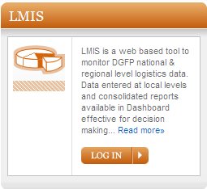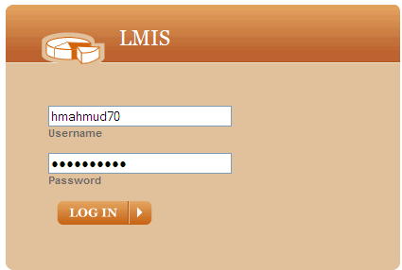

Dashboard

The first tab of the LIMS is Dashboard which showing two types of stock status of contraceptives:

- National Contraceptive Summary: Here you can see the stock status of major six contraceptives.

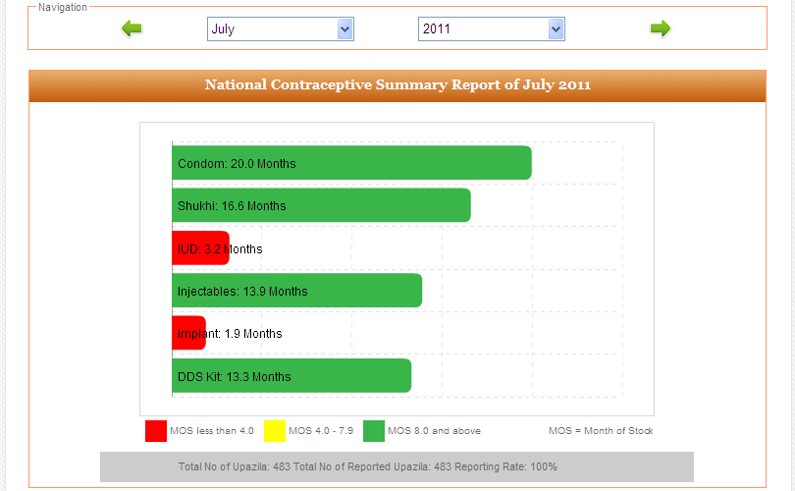

- Stock Status of Contraceptives at Warehouse: A bubble chart which shows stock status of major contraceptives at each of 21 warehouses of DGFP.

- Stock Status of Contraceptives at Upazila: Shows stock status of major contraceptives at each of 483 upazila stores of DGFP. Stock status of both upazila store and field level (stock at hand of service delivery points) is available.

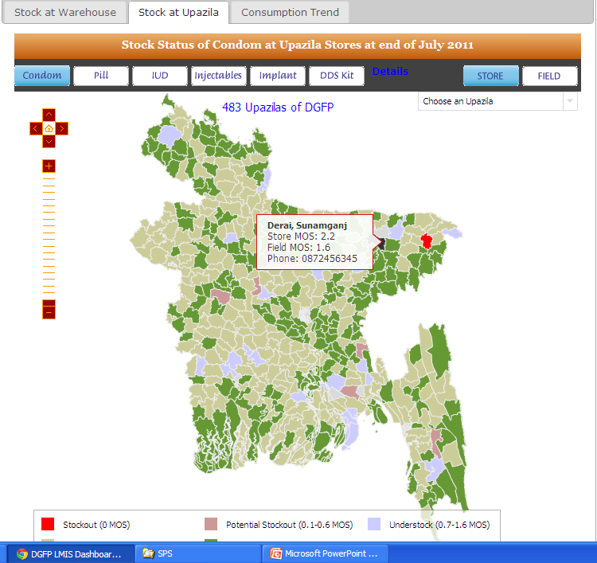

- Consumption Trend: A line graph is being used for showing each of the six major contraceptives consumption pattern in a year separately.

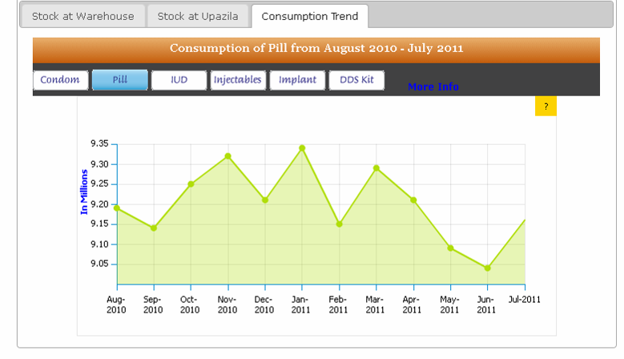

LIMS REPORT
LIMS Report tab contains 10 (Ten) reports based on LMIS data -

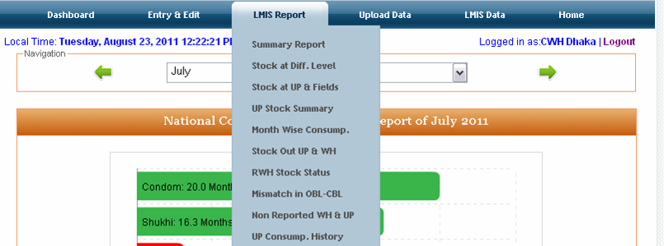

Report 1: Summary Report of Contraceptives of a month

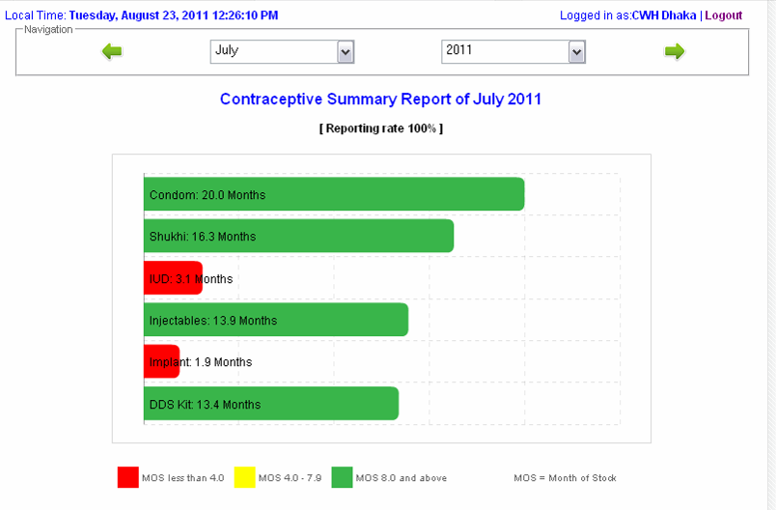
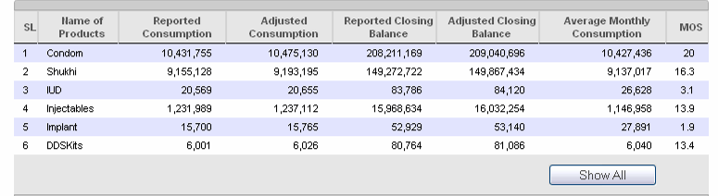

Report 2: Stock Status at Different levels of Contraceptives of a month

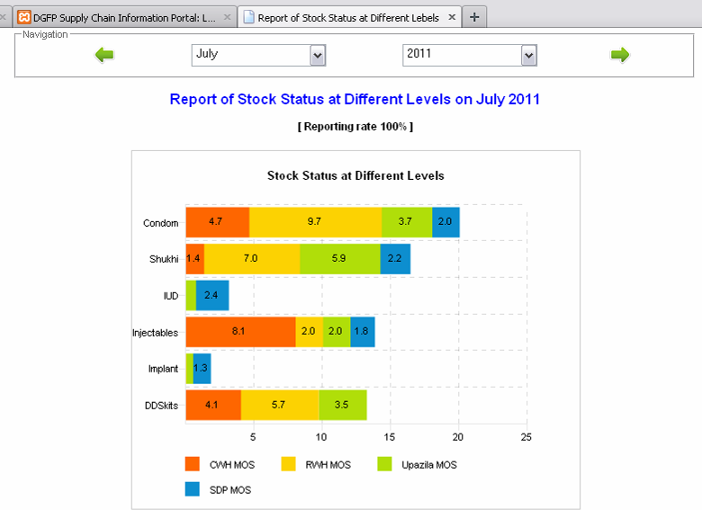
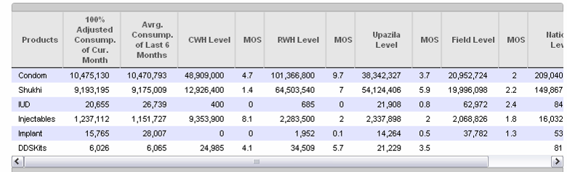

Report 3: Stock Status of Contraceptives at Upazila and Fields levels of a month

Report 4: Stock Status at Upazila and Fields of a month

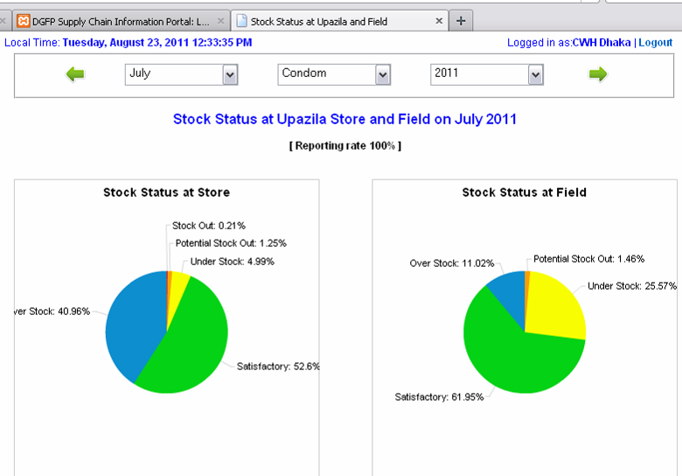

Report 5: Month-wise consumption of contraceptives for a year

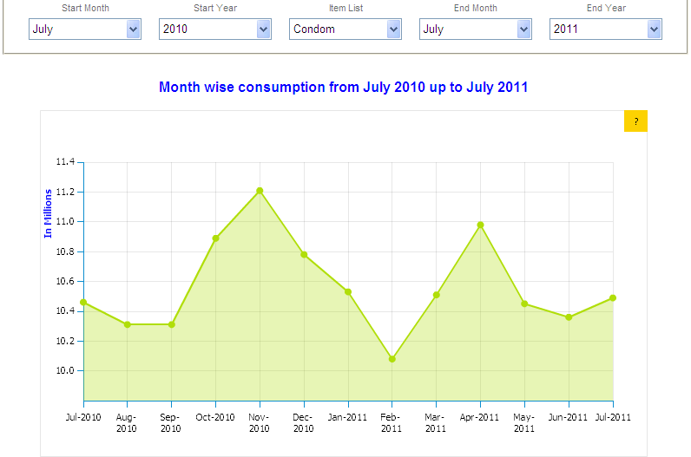
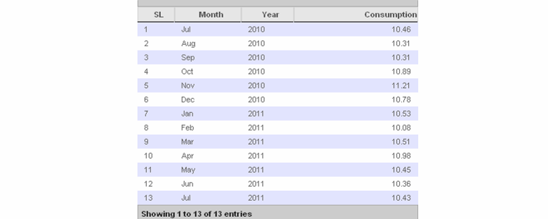

Report 6: Report of Upazila & Warehouse having Stock-out

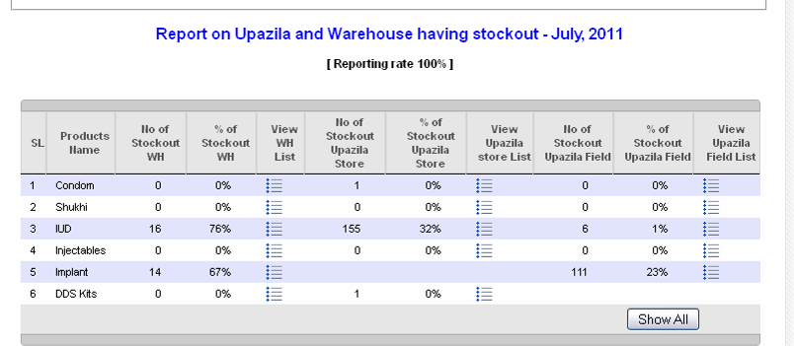
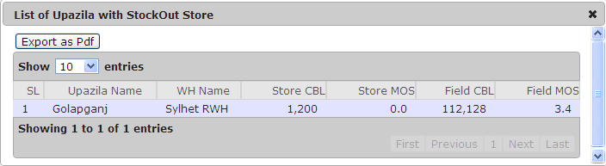

Report 7: Stock Status report at Regional Warehouses (RWH) on a month

Report 8: Balance Miss-match Report at Upazila and Field on a month

Report 9: List of Non Reported Warehouses and Upazilas on a month

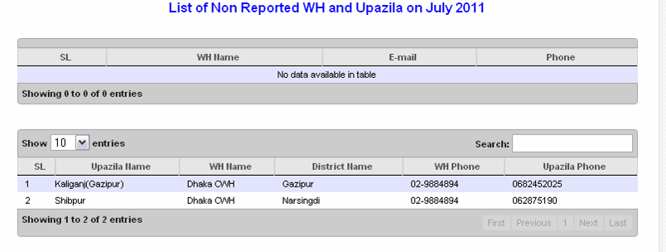

Report 10: Consumption History of a Contraceptive at a Upazila in a year

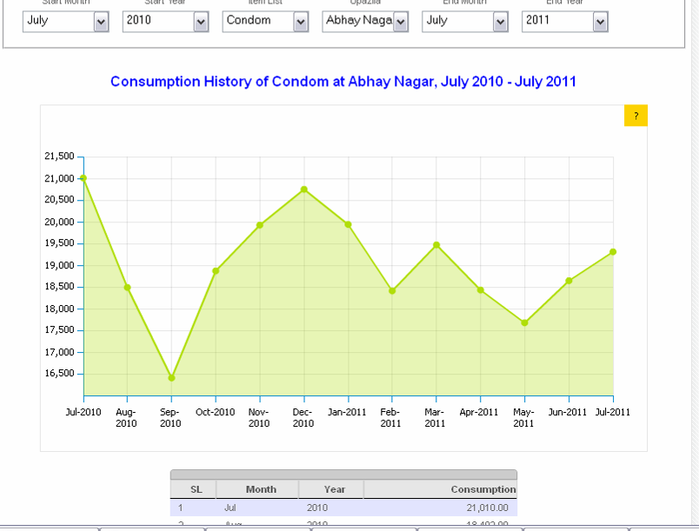

LMIS DATA
In the LMIS another Tab is LMIS Data which has 3 (Three) Reports:
- View F7 Data
- View F7B Data
- View UP Info

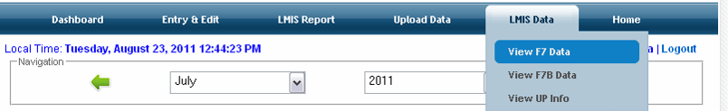

The first LMIS Data Report is List of Reported Warehouses of a month –

Clicking on any report will show the complete submitted report below the list –

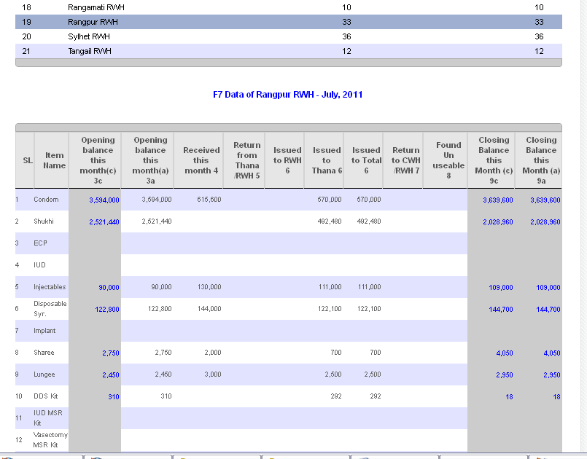

The second LMIS Data Report is List of Reported Upazilas of a month -

Clicking on any report will show the complete submitted report below the list -

The third LMIS Data Report is List of Upazilas -

Stock Status Report

If you have not logged on already, click on the LOG IN button under the Stock Status Report box, and provide your username/password in the boxes and press LOG IN button again. This will open the Stock Status Report page.

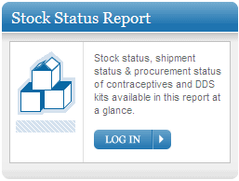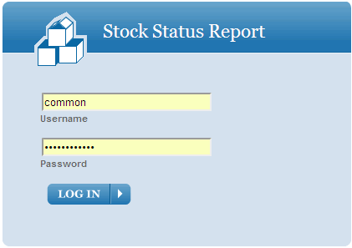

Stock Status report is prepared monthly to monitor current inventory, stock in pipeline & procurement plans in a single report to track MOS status of major contraceptives.

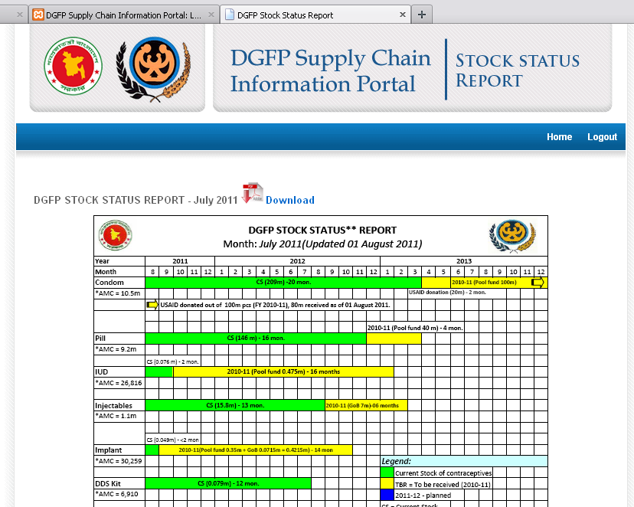

The report is prepared monthly and uploaded in the site and available as pdf download. Brief description about status of each commodity is available.
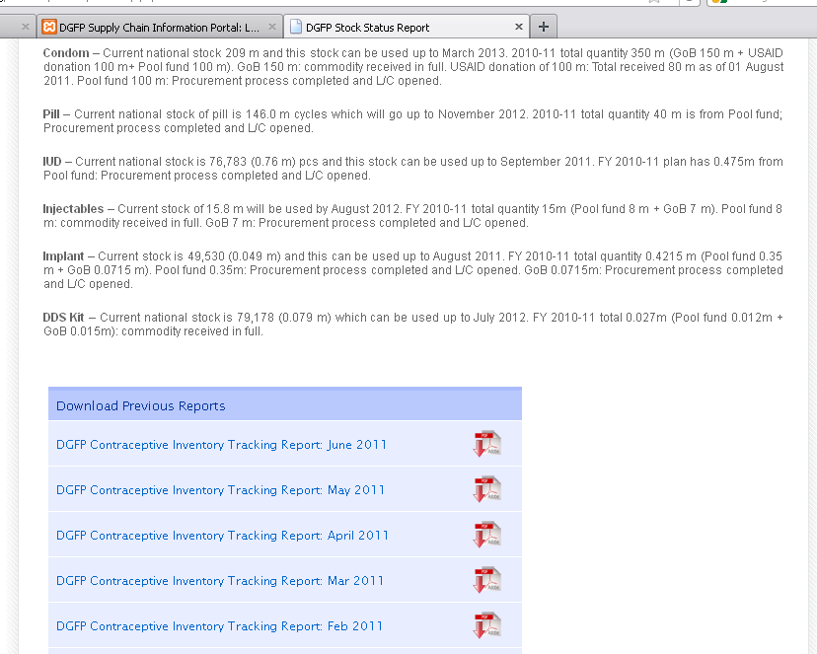

Previous month’s reports are also available in the page.

Operational Status of Tools

This module monitors status of two tools – UIMS & WIMS. If you have not logged on already, click on the UIMS blue link to go to the log in page. Provide your username/password in the boxes and press LOG IN button. This will open the UIMS Operational Status page.

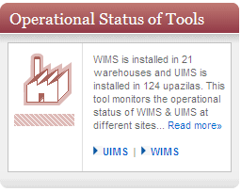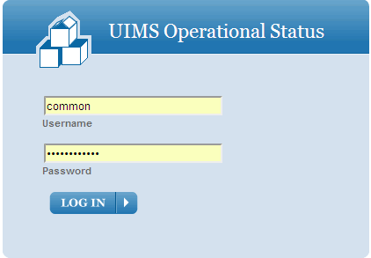

Operational status of uims
The Upazila Inventory Management System (UIMS) is a software to maintain inventory at Upazila (Sub-district) family planning stores. It enables Upazila Family Planning Store staff to maintain stock of commodities, monitor field reporting, generates supply plan, automated issue voucher generation & automated monthly Logistics Management Information System (LMIS) reporting. UIMS software has been installed in 145 upazilas. The page shows the status of UIMS upazilas – whether software is operational or not. Red mark means that UIMS is not operational in that upazila & blue means operational upazila.

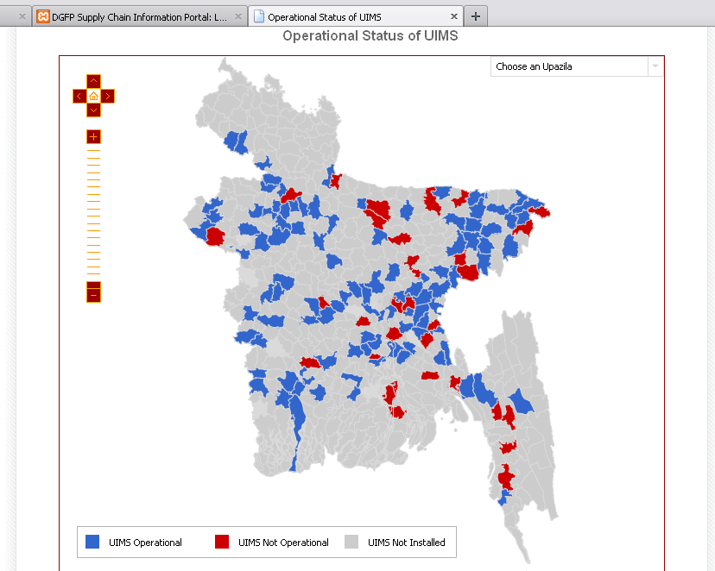

Putting the cursor over any non-functioning upazila will show the reason of the status.

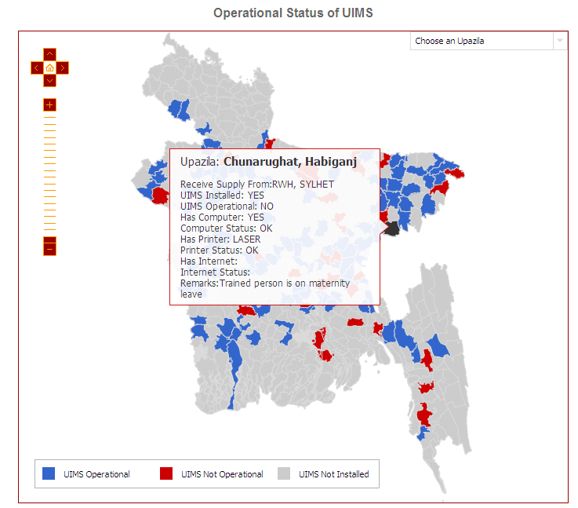

Below the map is the list of upazilas -

To view the reason/details UIMS status of an Upazila, you need to click “More” button and following screen will appear.

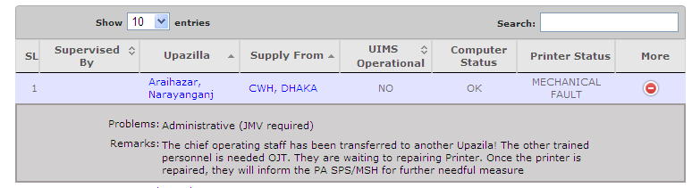

wims operational status
The Warehouse Inventory Management System (WIMS) is a software to maintain inventory at family planning warehouses at district level. It enables warehouse staff to maintain stock of commodities & monthly Logistics Management Information System (LMIS) reporting. WIMS was developed by USAID|DELIVER Project and currently maintained by SPS.

If you have not logged on already, click on the WIMS blue link to go to the log in page. Provide your username/password in the boxes and press LOG IN button. This will open the WIMS Operational Status page.

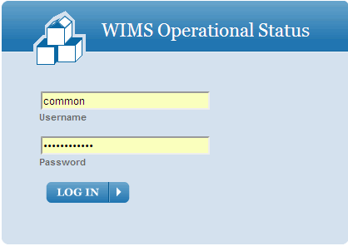

The map shows status of WIMS software status at 21 regional warehouses of DGFP. Putting a cursor on any warehouse point will show details of that warehouse computerization status.

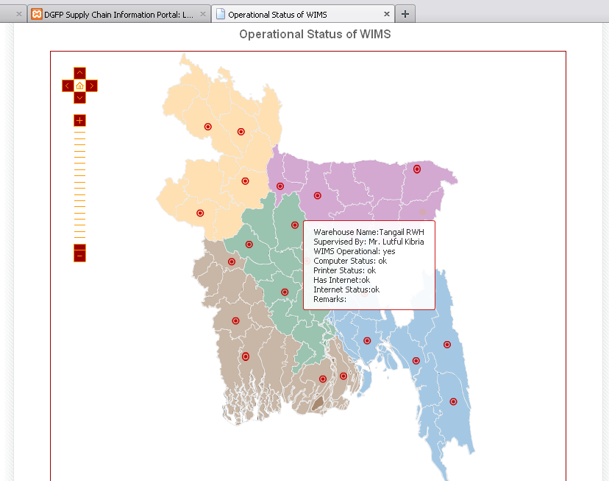

Below the map is the list of warehouses with status –

Menu

About DGFP

DGFP Supply Chain System

DGFP Logistics Tools

Discussion Board

Discussion Board allows DGFP personnel to discuss about their queries, ask for logistics & procurement related clarifications, comments regarding existing circulars etc.. The board needs separate registration. Only registered users are allowed to discuss in the board.

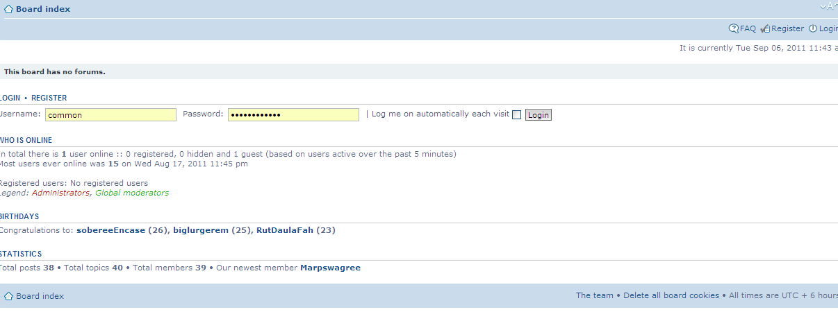

DGFP Logistics News

Documents

Following documents are available for download. Click on any of the document name or icon to download.
Contact Us

If you have any comments, feedback about the portal or would like to get access to the data, please fill in the form below and submit.

DGFP Tender Notices

This page will contain the Tender Notices for commodity & service procurement for DGFP.

